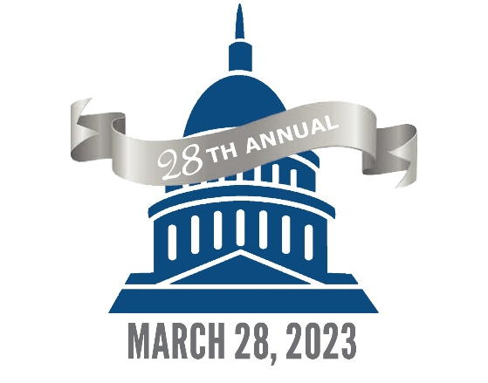
RESEARCH DAY AT THE CAPITOL

ABSTRACT FORM
NOMINATION DEADLINE: DECEMBER 1, 2022

By submission of this document, the Nominated Student signing digitally below, in consultation with their advisor, confirms that the provided abstract meets all requirements outlined on this form.

- NOMINATED STUDENT: (Digital/typed signature): Click here to type first/last name.
- UNIVERSITY REPRESENTED: Click here to type university name.

Abstracts MUST INCLUDE the following components:
- Student's Name
- Abstract Title
- Introduction
- Methods
- Results
- Conclusion
- Relevance of the Study
Separate/individual sections are not required for items 3-7, but each component must be addressed in the body of the abstract.

Additional abstract guidelines:
- Abstracts must be the work of the student and cannot exceed 350 words.
- This Abstract Form and the student’s Abstract must be submitted online as a part of the institution’s nomination package; the documents must be uploaded as individual/separate files.
- Name each document per the student's name (i.e. lastname_firstname_abstract.docx; lastname_firstname_abstractform.docx).
- Abstracts will ONLY be accepted in MS Word format (.doc or .docx) - no PDF or image files are allowed.
Note: Student researchers will have an opportunity to update/revise their original abstracts after nomination packages have been submitted/confirmed. Revisions will be accepted until Feb. 1, 2023 (11:59 p.m. CT).

